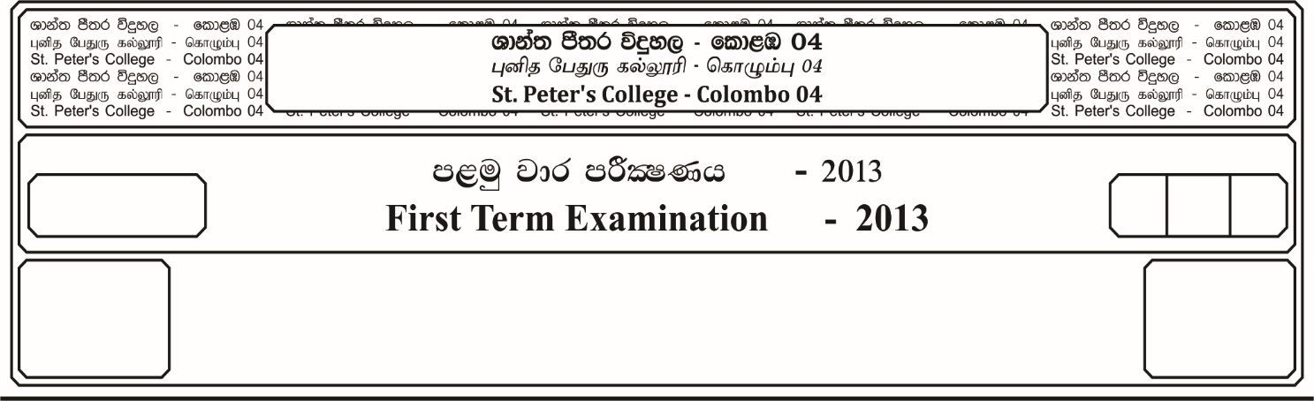

E

**f;jk jk jdr mÍCIKh - 2023**

**Third Term Examination - 2023**

l%sia;shdks O¾uh - ¸¸

**CHRISTIANITY – II**

II

12 fY%aKsh

GRADE 12

meh

Hour

43

03

**Part – I**

* Answer 05 questions selecting 02 questions from Part I and 03 questions from Part II.

01. i. Name the two books of the Holy Bible, which contains what the early prophets said and did. ***(02 Marks)***

ii. Write two main teachings of the prophets. ***(04 Marks)***

iii. Explain in brief who Messiah is according to prophet Isaiah. ***(06 Marks)***

iv. Describe in four points the way you put into action the life example of prophet Amos in today’s society. ***(08 Marks)***

02. i. Write the two purposes of St. Paul’s third missionary journey. ***(02 Marks)***

ii. Write the participants of the 1st missionary journey of St. Paul. ***(04 Marks)***

iii. Mention three significant points written in St. Paul’s 3rd missionary journey. ***(06 Marks)***

iv. Explain in 04 points how you would act for the progress of the Christian church as St. Paul made effort for the progress of both the Christians and Christians church through his epistles. ***(08 Marks)***

03. i. Name 04 prophets in the Bible. ***(02 Marks)***

ii. Name 02 points about synoptic Gospels. ***(04 Marks)***

iii. Describe 02 similarities apparent in the synoptic Gospels with examples. ***(06 Marks)***

iv. Mention your contribution to the society in spreading of the Gospel values among the youth. ***(08 Marks)***

**Part – II**

04. i. Describe 10 ways of spreading the word of God. ***(10 Marks)***

ii. Describe 05 occasions in which people of Israel experienced divine providence during the journey in the desert. ***(10 Marks)***

05. i. Describe five characteristics of the 10 commandment. ***(10 Marks)***

ii. Explain using five commandments out of 10, how you, as a student make use of them to live a life fostered with values. ***(10 Marks)***

06. i. Describe what is love according the teaching Christ. ***(10 Marks)***

ii. Christian family is the lifeline of the church, support your answer with examples.

***(10 Marks)***

07. i. All the Psalms of the Holy Bible can classified under seven categories. Mention five of them and describe. ***(10 Marks)***

ii. Summerize Psalms 23 and explain the relationship between Christ and his mission here on earth. ***(10 Marks)***